|  |  |
| --- | --- |
| **NOMBRE DEL EQUIPO** | PINK SLASHERS |
| **RAZA** | Elfos Oscuros |
| **ENTRENADOR** | Santi |



|  |  |  |  |  |  |  |  |  |  |  |  |  |
| --- | --- | --- | --- | --- | --- | --- | --- | --- | --- | --- | --- | --- |
| **Nº** | **POSICIÓN** | **MO** | **FU** | **AG** | **PA** | **AR** | **HABILIDADES** | **PRECIO** | **PTS. ESTR** | **PPP** | **+1 HERIDA** | **VALOR ACTUAL** |
| 1 | Linea | 6 | 3 | 2+ | 4+ | 9+ |  | 70.000 |  |  |  | 70.000 |
| 2 | Linea | 6 | 3 | 2+ | 4+ | 9+ |  | 70.000 | 4 |  |  | 70.000 |
| 3 | Linea | 6 | 3 | 2+ | 4+ | 9+ |  | 70.000 |  |  |  | 70.000 |
| 4 | Linea | 6 | 3 | 2+ | 4+ | 9+ |  | 70.000 |  |  |  | 70.000 |
| 5 | Linea | 6 | 3 | 2+ | 4+ | 9+ |  | 70.000 |  |  |  | 70.000 |
| 6 | Linea | 6 | 3 | 2+ | 4+ | 9+ | Solitario (4+) | 70.000 |  |  |  | 70.000 |
| 7 | Blitzer | 7 | 3 | 2+ | 4+ | 9+ | Placar | 100.000 | 2 |  |  | 100.000 |
| 8 | Blitzer | 7 | 3 | 2+ | 4+ | 9+ | Placar | 100.000 |  |  | +1 HERIDA | 100.000 |
| 9 | Blitzer | 7 | 3 | 2+ | 4+ | 9+ | Placar, Esquivar | 100.000 |  |  |  | 120.000 |
| 10 | Bruja Elfa | 7 | 3 | 2+ | 5+ | 8+ | Esquivar, Furia, En pie de un salto, Placar | 110.000 | 2 |  |  | 130.000 |
| 11 | Linea | 6 | 3 | 2+ | 4+ | 9+ |  | 70.000 | 4 |  |  | 70.000 |
| 12 |  |  |  |  |  |  |  |  |  |  |  |  |
| 13 |  |  |  |  |  |  |  |  |  |  |  |  |
| 14 |  |  |  |  |  |  |  |  |  |  |  |  |
| 15 |  |  |  |  |  |  |  |  |  |  |  |  |
| 16 |  |  |  |  |  |  |  |  |  |  |  |  |

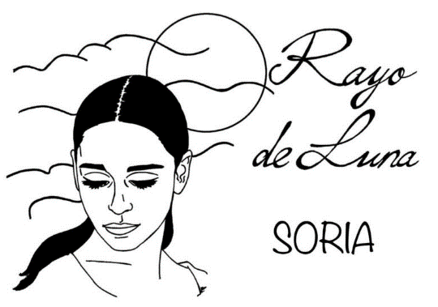

|  |  |  |  |  |  |  |
| --- | --- | --- | --- | --- | --- | --- |
| TESORERÍA | 25.000 |  | RE-ROLLS | 2 | X 50.000 mo | 100.000 mo |
| FACTOR HINCHAS | 2 | ASISTENTES DE ENTRENADOR |  | X 10.000 mo |  |
| TD AVERAGE |  | ANIMADORAS |  | X 10.000 mo |  |
| TOTAL HERIDAS |  | APOTECARIO | 1 | X 50.000 mo | 50.000 |
|  |  |  | FANS | 1 | X 10.000 mo |  |
|  |  |  | TEAM VALUE | 1.090.000 | | |